**DAYANANDA SAGAR UNIVERSITY**

**DEPARTMENT OF COMPUTER SCIENCE & ENGINEERING**

**SCHOOL OF ENGINEERING**

**DAYANANDA SAGAR UNIVERSITY**

**KUDLU GATE**

**BANGALORE - 560068**



PROJECT TITLE : COIN BASED MOBILE CHARGER

SUBMITTED TO THE VIth SEMESTER

MINOR PROJECT 2020

***Submitted by***

**Abhishek Singh (ENG17CS0008)**

**Amruth Reddy K(ENG17CS0029)**

**Anoop MR (ENG17CS0035)**

VI semester ‘A’ sec

***Under the supervision of***

Dr . Vinod Agarwal

**ABSTRACT**

The coin based mobile charging system charges the mobile phones when the coin is inserted. This system is used by shop owners, rural people and can be implemented in the public places like railway stations, bus stand to provide mobile charging facility. So the coin acceptor recognizes valid coins and then signals the Arduino for further action. If a valid coin is found, it signals the Arduino and then Arduino starts the mobile charging mechanism providing a 5V supply through a power supply section to the mobile phone. The Arduino starts a reverse countdown timer to display the charging time for that mobile phone. Further the user adds another coin, the Arduino adds to the currently remaining time and once again decrements the countdown. This system can be used for smart mobile charging at public places. This coin based mobile charging system will supply the enough amount of charge to the mobile phone and is available on demand in public places.

**INTRODUCTION**

The usage of mobile phones is increasing in many folds. Hence, charging the mobile phones has become a greater task these days. Battery power is the main concern when buying new mobile phones. The main purpose of mobile charger is to reduce the wastage of electrical power which often arises due to negligence of the user. Once the coin is inserted, the coin acceptor detects whether the coin is valid or not. For each unit of price, the power is available only for a limited period. The Arduino can calculate the time based on the number of coins inserted.

**LITERATURE REVIEW**

In recent times, there have been lots of advancements in technologies being developed for charging the mobile phones. In most cases solar energy is used for charging the mobile phones. Solar energy converts light energy into DC current that can be used for charging the mobile phones. A fixed solar panel of size 635x550x38mm, 37WP is used to charge the mobile phones up to maximum 2.0 amp.

The Infra-Red Sensor is another way to charge mobile phones. The Infra-Red transmitter transmits IR signals in the transmitter side and receives the IR signal in the IR receiver side. Based on the signal between the IR transmitter and receiver, insert a coin to change the polarity of pulse in SCU input. The SCU converts low pulse to high pulse and fed as input into driver circuit and driver circuit provides sufficient input voltage of relay. This will be used for charging the mobile phones. The microcontroller performs the countdown time period for a 3 minutes, with LCD display shows the actual time left. During the time period a relay was out latch and finishing time in progress.

In it experimentally investigated the working of Coin based mobile charger with solar tracking system by peak power positioning .In this experiment the operational amplifiers can operate the ON/OFF and directional functions of the structured five motors. These motors rotate in two axes. The tracker’s sun sensor is mounted. From the output of this device it will check the outputs are all equal, then the collector structure is nearly perpendicular to the sun and tracking error is reduced.

According to, the renewable energy is the main source of one of the renewable energy sources is solar energy. This energy generated more energy because the solar panel is to maintain a perpendicular to the sun’s rays. By using an IoT, the mobile phone can be charged. In this scenario, it monitors the solar energy as well as battery power when the coin is inserted in the coin box. Once the coin is detected, it sends signal to the Raspberry pi and it trigger the relay and the LCD display show the countdown time. The Raspberry pi can collaborate with the outside world. The relay generates the voltage and fed as input to mobile phones. There are various technologies evolved for charging the mobile phones in our world .

**COMPONENT DESCRIPTION**

The key components for the project are

* ARDUINO BOARD
* LCD
* COIN SENSOR
* RELAY

**Arduino Board**

Arduino Uno is a microcontroller board based on the ATmega328P. It has 14 digital input/output pins (of which 6 can be used as PWM outputs), 6 Analog inputs, a 16 MHz quartz crystal, a USB connection, a power jack, an ICSP header and a reset button. As shown in Fig 3, it contains everything needed to support the microcontroller . In order to get it started, it is essential to simply connect it to a computer with a USB cable or power it with a AC-to-DC adapter or battery.

Arduino works only when the signal receives from the coin box. And this Arduino is ON 5V supply which comes on the voltage regulator. The Arduino give the 1us pulse at each USB and then it applied to the timer which gives coin. The Arduino which is connected to the LCD will display message, if coin is correct detected then it will accept Otherwise, It will goes to refund box.

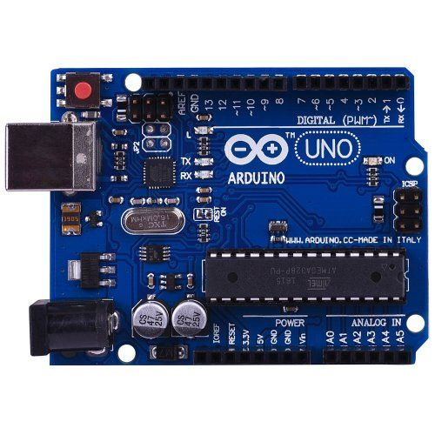

**LCD**

LCD's typically have 14 data pins and 2 for the LED backlight. Character LCDs use a standard 14-pin interface and those with backlights have 16 pins. There may also be a single backlight pin, with the other connection via Ground or VCC pin. The two backlight pins may precede the pin 1. The nominal backlight voltage is around 4.2V at 25˚C using a VDD 5V capable model. Character LCDs can operate in 4-bit or 8-bit mode. In 4 bit mode, pins 7 through 10 are unused and the entire byte is sent to the screen using pins 11 through 14 by sending 4-bits) at a time.

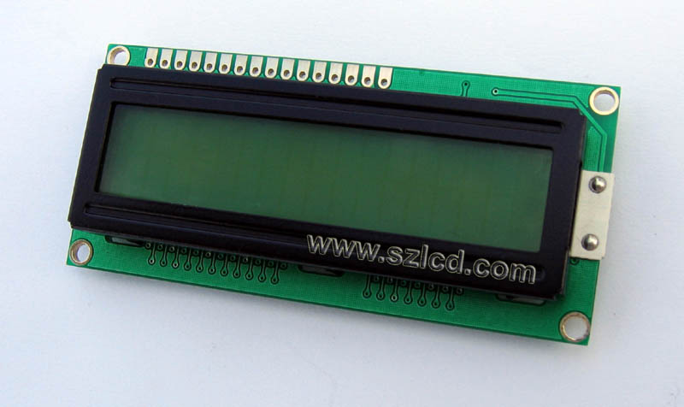

a) LCD

**COIN SENSOR**

A coin acceptor validates a coin/token based on physical properties such as weight, size and/or magnetic content and then sends a corresponding I/O signal to its output connector.

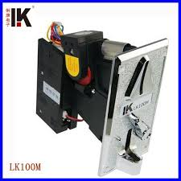

b) COIN SENSOR

**RELAY**

Relays are electromechanical switches. Relays are used throughout the automobile. Relays which come in assorted sizes, ratings, and applications, are used as remote control switches that are controlled by another switch, such as a horn switch or acomputer as in power train control module. Relays allow a small current flow circuit to control a higher current circuit.

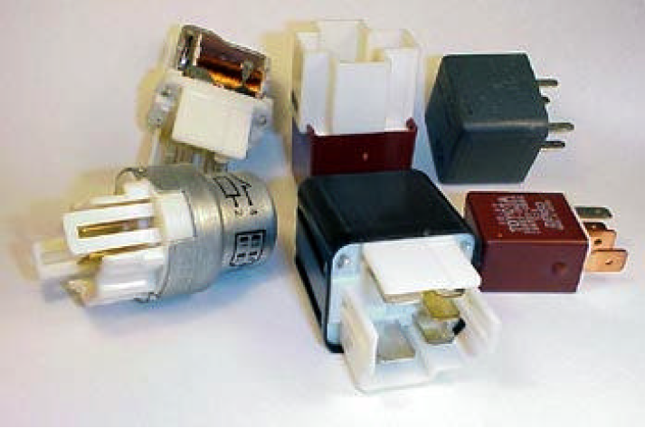c) RELAY

**SYSTEM ARCHITECTURE**

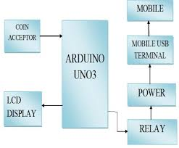

**WORKING PRINCIPLE**

The coin insertion based mobile charging system has two important components which function as the heart and brain of the entire system. The Arduino UNO board is the brain of the system and is interfaced with all the other components and controls the entire system.

The microcontroller is programmed in such a way that it takes the command from the coin insertion machine and accordingly it defines the time for which the phone will charge. The Arduino board is also interfaced with the keyboard and LCD where it takes the inputs from the keypad and displays instructions on the LCD display. The Arduino board also recognizes which slots are available and which slots are busy and will notify the user through displaying a notification. The Arduino board also provides the security to the slots which have a locking mechanism. It includes a metal lock which is driven by a motor and the motor is controlled by the motor driver circuit which is connected to the Arduino board. Depending upon the password entry the Arduino board creates password or verifies the password in order to open or close the slot with the help of motor driven metal lock provided to the slots. The coin insertion machine works on the principle of image processing. Once the user enters a specific coin for certain times then the various images are captured by the sensor present in the machine. These images are then processed and then identified by the value of the coin. Similarly the coin insertion machine can identify 4 such coins. Any other coin inserted into the coin insertion machine then will get rejected and will come out from the machine. Hence the entire system works efficiently with the help of all these principles and concepts.

The main input is taken from 230V AC mains power supply which then produces a 5V DC output after being rectified by the AC to DC converter to charge each phone. The phones are charged using standard USB cables. The USB cables are connected to switches controlled by the Arduino which can turn them ON or OFF for particular amounts of time depending upon the money inserted by the user. This project being just a prototype, charging for only two phones was designed. However for large scale real life implementation, wherein much more number of phones and slots come into picture, power dissipation and high power and current needs to be taken into consideration. In such cases, use of heat sinks and high power components would become mandatory.

**APPLICATIONS**

* Proposed system will be more effective on Railway Station, Bus Stops, Toll Nakas, and Metro Stations.
* It could be implemented on every square.
* It must be in villages which are without electricity power supply.
* Industrial application.

**ADVANTAGES**

* It will take easier to get mobile charged remote sensing, rural areas.
* No electric power supply needed.
* The coin based mobile battery charger can be easily and installed outside any Business premises.
* Simple and portable.
* Low power consumption.

**FUTURE SCOPE**

This project can be expanded in the future to include different charging mechanisms including the use of solar power in case of a main line power failure, which can be extremely beneficial especially in rural areas where there are constant power cuts.

Additionally, an OTP provided to the user on an alternate mobile number using GSM can also be provided for additional security. The entire system can also be connected online.